

Keeping Things Fresh and Clean in Homestay

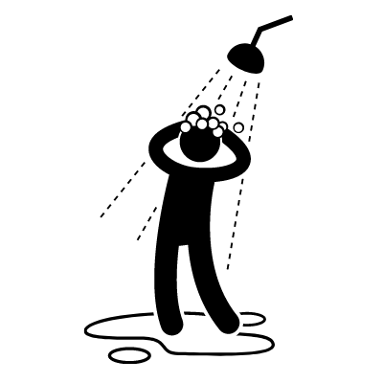 | In the Bathroom  - The Australian climate is generally quite hot so taking a shower, wearing clean clothes and a using a good deodorant every day is very important.  - It is common to shower at least once a day in Australia.  - Use soap or body wash to clean all over your body, and make sure to rinse off completely.  - You may want to have an extra shower after exercising, going to the gym or playing sports.  - Wash your hair regularly with shampoo and conditioner (typically every 2–3 days, depending on your hair type).  - Other members of the household need to use the bathroom so please limit shower times to 10 minutes or less > this also helps to save water.  - Australians wash inside the bath or shower cubicle so water does get onto the bathroom floor.  - Please do not stand outside the bath or shower to splash water over yourself.  - The sink is used by family members to clean their teeth or wash their face. Please do not wash your body at the sink.  - There is usually a bath mat on the floor. Stand on that when you get out of the shower so you do not slip over.  - When using the bathroom, close the door and lock it if possible.  After your shower:  - Please leave the bathroom clean.  - Wipe up any excess water from the sink and floor.  - Pick up any long hair and dispose of it in the rubbish bin.  - Pack up your personal belongings.  - Hang your towel up to dry after you use it. Check with your host family where you should hang your wet towel.  - Put on deodorant before your get dressed.  - Hang the bathmat up to dry.  - Brush your teeth at least twice a day (morning and night).  - You will need to have your own toothpaste and toothbrush.  - Turning off the tap whilst you brush your teeth.
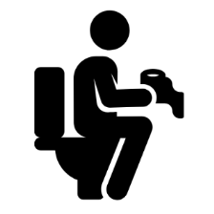 | Using the Toilet + Disposing of Sanitary Items  Toilet  - Australian toilets are built for sitting. Never squat or stand on the toilet seat.  - Use the toilet paper provided to wipe off once you have finished.  - Don’t use too much toilet paper as it may block or cause the toilet to overflow.  - Put used toilet paper straight in the toilet bowl and flush.  - Never flush anything down the toilet except for toilet paper.  - Always wash your hands with soap after using the toilet.  - Please wipe up any spills on the toilet seat with toilet paper.  - Please use the provided toilet brush to remove any marks left in the toilet bowl after you have finished.  Sanitary Items  - Don’t flush sanitary items such as tampons and pads down the toilet. You may cause a blockage!  - There will be a bin in the toilet or bathroom area for you to dispose of sanitary items.  - If there is no bin in the toilet/bathroom: wrap your pad or tampon in toilet paper, put it in a plastic bag, and then throw it in a garbage bin outside.
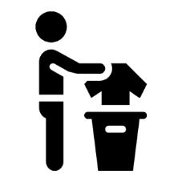 | Clothing + Laundry  - Change into clean clothes every day.  - If your clothes smell after wearing them, it is a good idea to wash them immediately. Don't leave clothes in a bag for too long.  - Because the weather is so nice in Australia, your hosts will probably hang their washing on a clothesline outside to dry instead of using a tumble dryer.  - If it is raining and there is no dryer, ask your host where to hang your clothes.  - Do your laundry regularly.  - Your host family may want you to do your own washing.  - They will instruct you on how the machine operates and how much detergent to use (if you put in too much it may damage your clothes).  - Full loads only please, 1-2 times per week.  - If you want to handwash your underwear, ask where you can do this. Most hosts do not like underwear to be washed in the bathroom sink and prefer you do it in the laundry.  - Once the washing is done, hang it on the clothesline to dry.  - Do not keep wet clothes in your bedroom.  - Ask your host if you would prefer to hang your underwear to dry in a private place.  - Some host may ask you to put your laundry items in a basket provided and your host will wash them for you.  - It is polite to offer to hang the clothes on the line or to bring them in when they are dry.  - Ask your host about changing bed sheets, pillow cases and towels. This will be done at least once every two weeks.
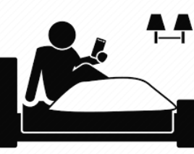 | Your Bedroom  - Keep your bedroom clean and tidy.  - In Australia, we sleep in the bed, between the sheets, with blankets on top.  - Make your bed every day and keep your personal items organised.  - Do not cook or keep food in your room. You might attract mice and cockroaches.  - Do not leave any wet clothing or towels in your room – the wetness can cause mould to grow and damage furniture.  - Do not stick anything to the walls. If you wish to hang anything, see your host.  - Empty your rubbish bin regularly (please use the correct bins for recycling and general waste).  - No smoking in your bedroom.  - If you are a smoker, ask where you may smoke (often this will be outside).
 | Healthy Habits + What to do if you Feel Sick  - Always wash your hands with soap and water before eating.  - If you're sick (cold, flu, etc.), make sure to wash your hands often, cover your mouth when coughing, and keep your living space clean.  - If you need to clear your nose or throat, use a tissue then throw it in the bin straight away. Wash your hands afterward.  - Tell your host if you are feeling unwell. They’ll advise you where the nearest medical centre is if needed.  - You may have to pay to see the doctor, however your OSHC may cover some medical costs. Dental and optical are not covered under your health insurance.  - 13SICK is the number for medical assistance after 6:00pm at night and before 6:00am in the morning.  - Visit ahnhomestay.co/medical-help-aus for more info.
 | General Etiquette  - If you make a mess anywhere in the home, please clean it up.  - If you are unsure what cleaning products to use, chat to your host and they will help.  - Please keep your possessions tidy and do not leave them around the house.  - If you are preparing food, please leave the kitchen clean and tidy afterwards.  - Your homestay hosts are not your servants – You are living as part of a family where everyone should respect each other. You are not living in a hotel where everything is done for you. Australian families rarely have staff to help with cooking or cleaning at home.

If you have any questions, feel free to ask your host.
They want you to have a comfortable and pleasant stay.

