**2018 AHN Aussie Gift Guide**

Can you believe this year is almost over?! Unless you’re enrolled to study during the summer semester in Australia, you’ve probably said goodbye to high school/college/university and have started planning your holidays. Ripper! Whether you’re staying in Oz to experience an Aussie Christmas or heading home to see your family, now is a good time to stock up on some unique gifts to give to your mates and/or loved ones. Check out our list of perfect pressies to get you started.

1. A cheap and cheerful selection of magnets showing off some Australia’s favourite icons including a lamington, fairy bread, hills hoist and a pair of thongs (also known as pluggers or flip flops). Useful and easy to pack in your luggage.

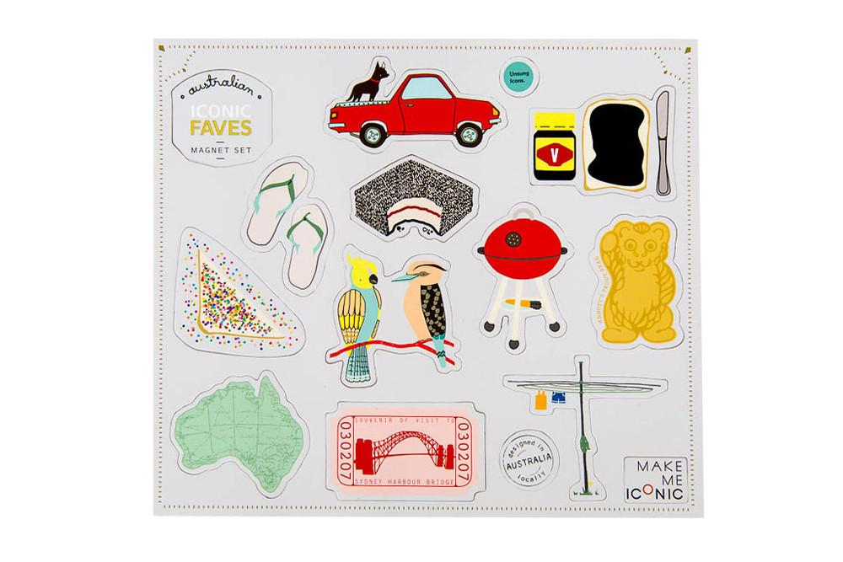

[Iconic Magnets – Faves](https://makemeiconic.com/products/iconic-magnets-faves) *Make Me Iconic* from $19.99AUD

2. Drying the dishes isn’t a fun job but at least there’s something awesome to look at if you’re using a tea towel like this. The simple sausage on bread is a symbol of Aussie culture. If you haven’t been to the local Bunnings hardware store for a sausage sizzle – you must go. It would be unAustralian not to.

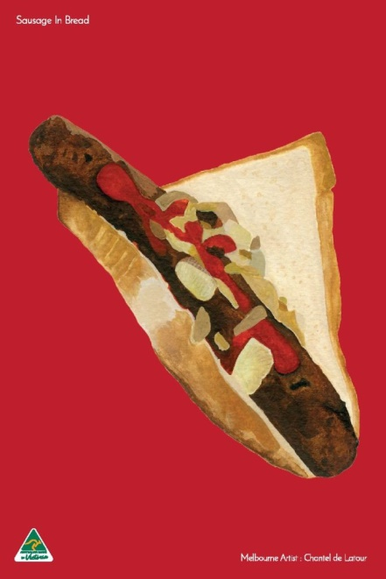

[Sausage in Bread Tea Towel](https://kedesign.com.au/product/tea-towel-sausage-in-bread-red/) *KE Design* from $24.99AUD

3. Australia has more than 60 wine regions across the country and a good bottle of wine is sure to be a welcome gift. [Langton’s](https://www.langtons.com.au/search?p=1&SortTerm=lowest_price&IncludeBuyNow=true) is an excellent guide to find some of the best drops in Oz. You can either order online or buy the ones you like from your local bottle shop. **You need to be 18 years or older to purchase and consume alcohol in Australia. Limits apply when transporting alcohol on flights.**



Search [*Langton’s Fine Wine*](https://www.langtons.com.au) for Australian wines

4. Which city have you been calling your home away from home? Sydney? Perth? Melbourne? The Gold Coast? These cool maps highlight the suburbs in Australia’s most popular destinations. Frame one up as a keepsake for yourself or give it to a friend so they can get to know the neighbourhoods where you’ve been hanging out.

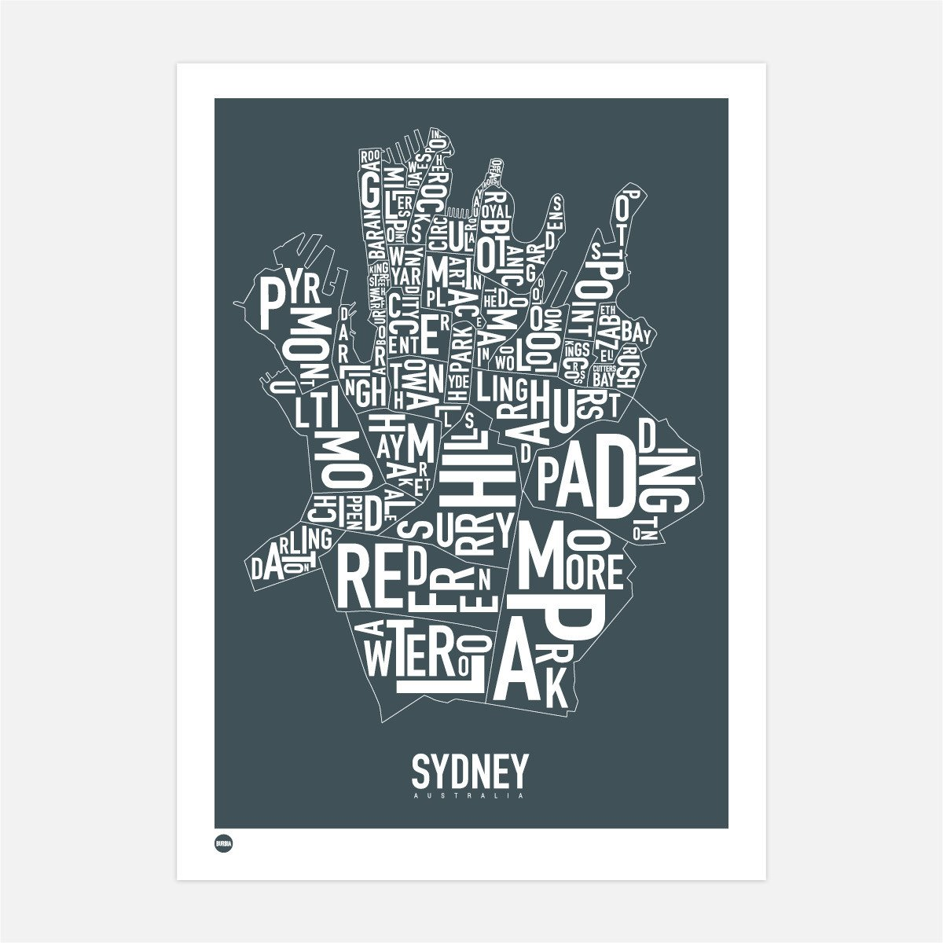

[Sydney Type Map](https://www.burbia.com.au/products/sydney-type-map?variant=9237580421) *Burbia* from $34.99AUD

5. Crikey, check this out! Steve Irwin is an Aussie legend whose crazy antics and love for wildlife conservation made him famous around the world. The Australia Zoo online store has everything from khaki Crocodile Hunter shirts to plush toy animals and drink coolers. You’re sure to find a souvenir with character.

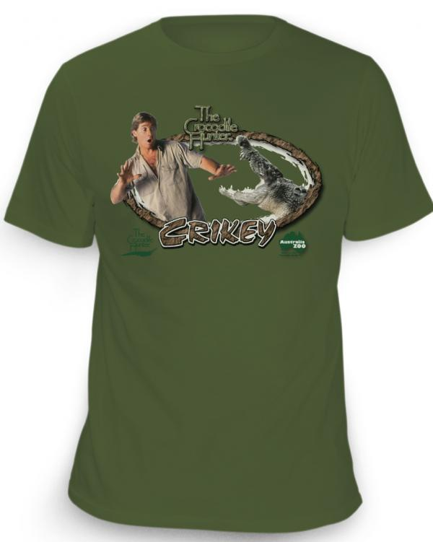

[Crikey T-shirt](https://shop.australiazoo.com.au/) *Australia Zoo* from $29.95AUD

6. Our student guests often tell us one of the best things about living in homestay is learning Aussie slang from their hosts. These magnets are a great way to help you remember the best phrases and teach others what you’ve learned.

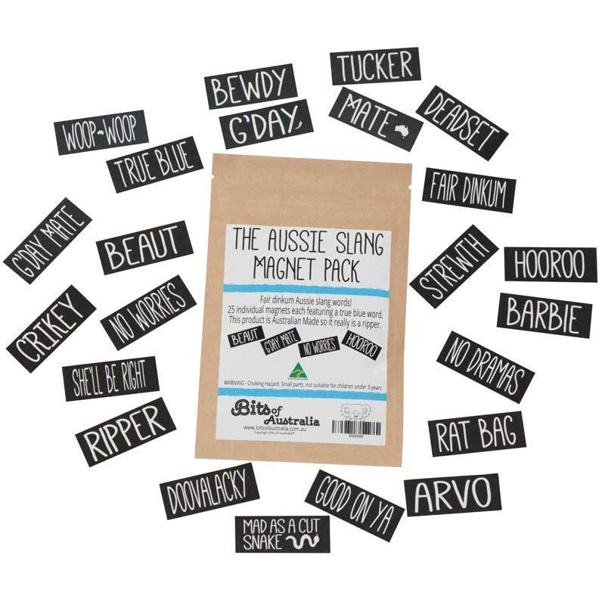

[The Aussie Slang Magnet Pack](https://www.bitsofaustralia.com.au/collections/all-australiana/products/aussie-slang-words-40-mini-magnets) *Bits of Australia* from $8.95AUD

7. Giving someone a selection of iconic Australian foods will help them get a real taste for what the Land Down Under has to offer. You can either send a ready-made gift box like these or head to your local supermarket and pick up some goodies to share. We recommend Vegemite, Tim Tams, Caramello Koalas, Fantales, Arnott’s Barbecue Shapes, Twisties, some honey and even macadamia nuts.

[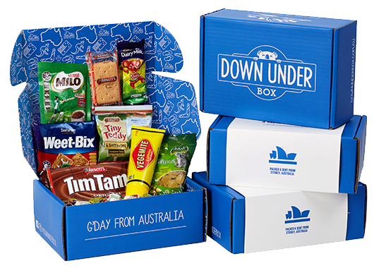](https://cdn.shopify.com/s/files/1/0918/9284/t/17/assets/dub-overhead.png?2842424082433673819)

[Aussie Gift Box](https://www.downunderbox.com.au/collections/aussie-care-packages) *Down Under Box* from $50.00AUD

8. Footy. Cricket. Netball. Have you become a sports fan since coming to Australia? Wear your team colours and take home a legit souvenir from your time in Oz. Grab a jersey or go casual with a t-shirt, cap or hoodie.

[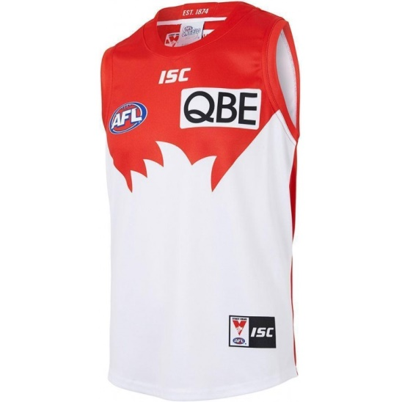](https://www.fangear.com/sydney-swans-2018-mens-home-guernsey.html)

[Sports Merchandise](https://www.fangear.com/) *Fangear.com* Prices vary

9. Ornaments are small, cute and can really capture the Australiana vibe in a festive way. You can go for something familiar to hang on your Christmas tree like a koala or kangaroo, or pick a decoration that’s a bit more unusual like a magpie or penguin.

[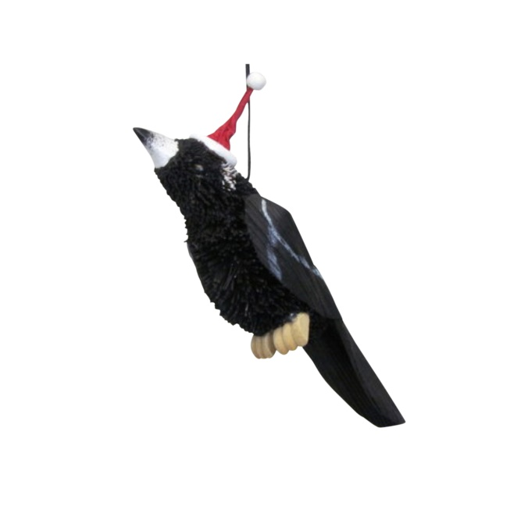](https://cdn2.bigcommerce.com/server4600/630c7/products/425/images/2901/XORN_MP__08414.1402460547.1280.1280.jpg?c=2)

[Australian Decorations](https://www.christmaselves.com.au/australian-christmas/) *Christmas Elves* from $7.95AUD

10. With our sunny climate and beautiful beaches, it’s not unusual to spend a lot of your time wearing a swimsuit. The term “[budgie smugglers](https://en.oxforddictionaries.com/definition/budgie_smugglers)” is an Australian phrase you may have come to know and this range of locally-made swimwear really shows off what the Aussie lifestyle is all about.

[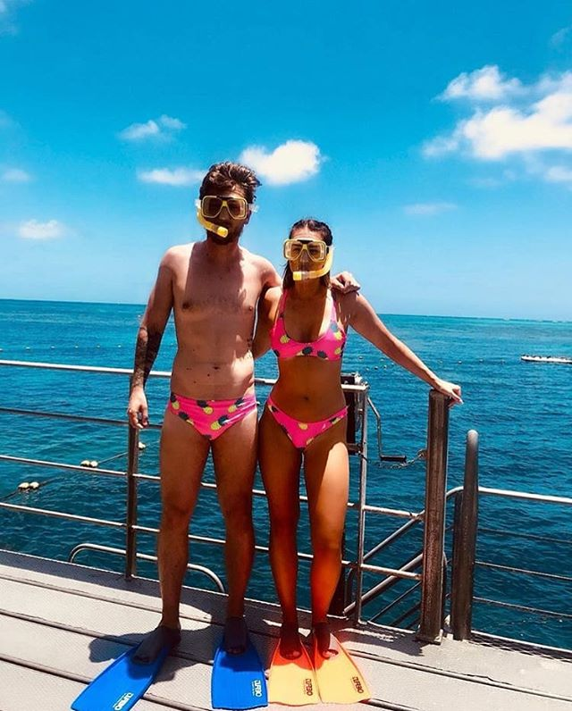](https://scontent-syd2-1.cdninstagram.com/vp/c0b6aad25e29d452c94f1c6fedd92d05/5CB1C070/t51.2885-15/e35/42181997_479708102517331_3211466928721455341_n.jpg)

[Mens and Womens Bathing Suits](https://budgysmuggler.com.au/) *Budgy Smuggler* from $50AUD

*Product prices and availability are accurate as of the date/time of publishing and are subject to change.*